Document A

Receipt for Schooling Your Black Girl

Original Transcription

May the 4 1788
M^{rs}
Derby to Hannah Masurey D^{r}
to one quarters schooling your Black girl £ 0 = 9 = 0
to one quarters schooling betsy Browne 3/ . . .0 = 3 = 0
Received Payment Hannah Masurey

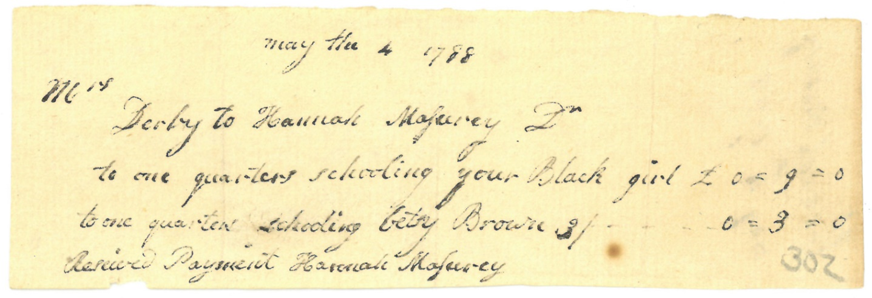

Image Source
Derby Family Papers, MSS37, Box 17 Folder 4
Courtesy of The Phillips Library, Peabody Essex Museum, Salem, Mass.

Document B

Receipt for School Rose
Original Transcription

August the 3^{d} 1788
Mrs Derby to Hannah Masurey D^{r}
to one quarters schooling Rose - £ 0 = 9 = 0

August the 14 Received Payment
Hannah Masurey

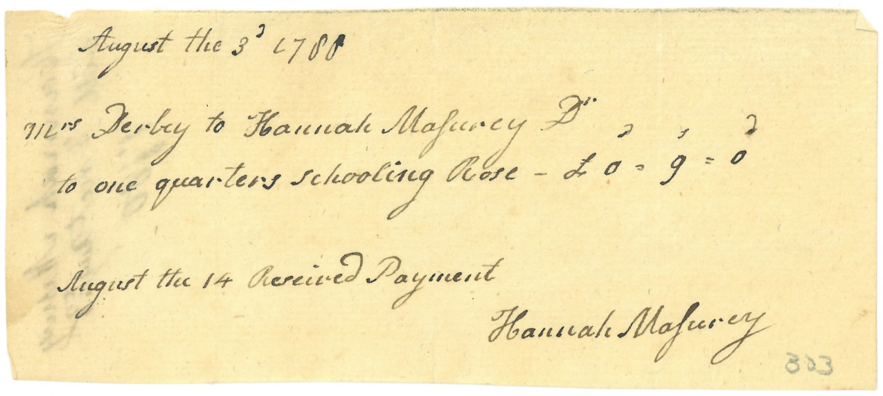

Image Source
Derby Family Papers, MSS37, Box 17 Folder 4
Courtesy of The Phillips Library, Peabody Essex Museum, Salem, Mass.

Document C

Elias Hasket Derby Will

Original Transcription

Page 1
I do hereby give & bequeath unto my Negro man Saba
the sum of two hundred & fifty dollars.
I do hereby give & bequeath unto my young Negro woman
Rose the sum of two hundred & fifty dollars.
And
Page 2
And I order and direct my Executor to pay the two last mention
-ed Legacies given to the said Sabe & Rose unto my said daughter
Martha;___ and my Will is that my said daughter Martha putout
the same on Interest and pay over to the said Saba & Rose the
principal Sum and Interest in such proportions and at such
Times, as she may think proper.

Document C (page 1)
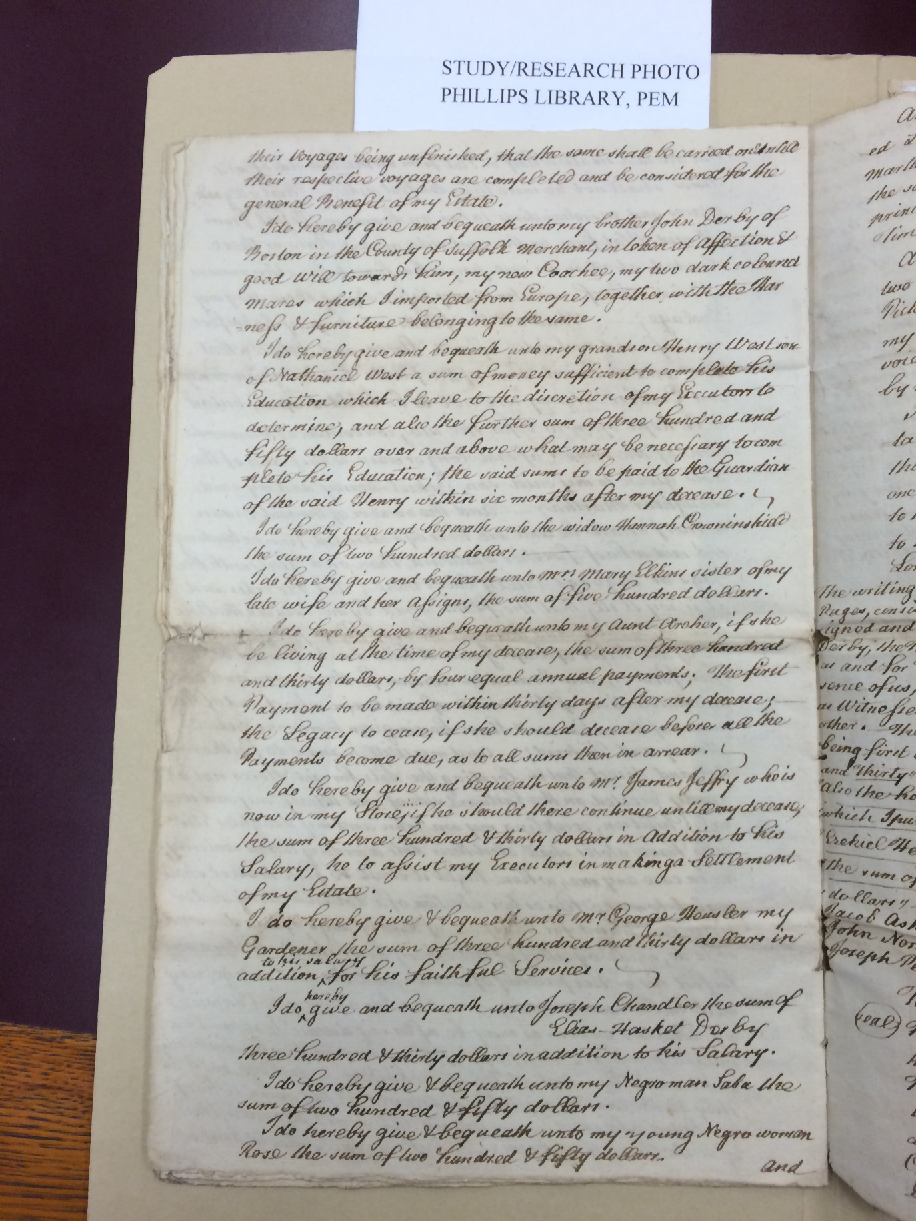
Image Source
Derby Family Papers, MSS37, Box 19 Folder 1
Courtesy of The Phillips Library, Peabody Essex Museum, Salem, Mass.

Document C (page 2)

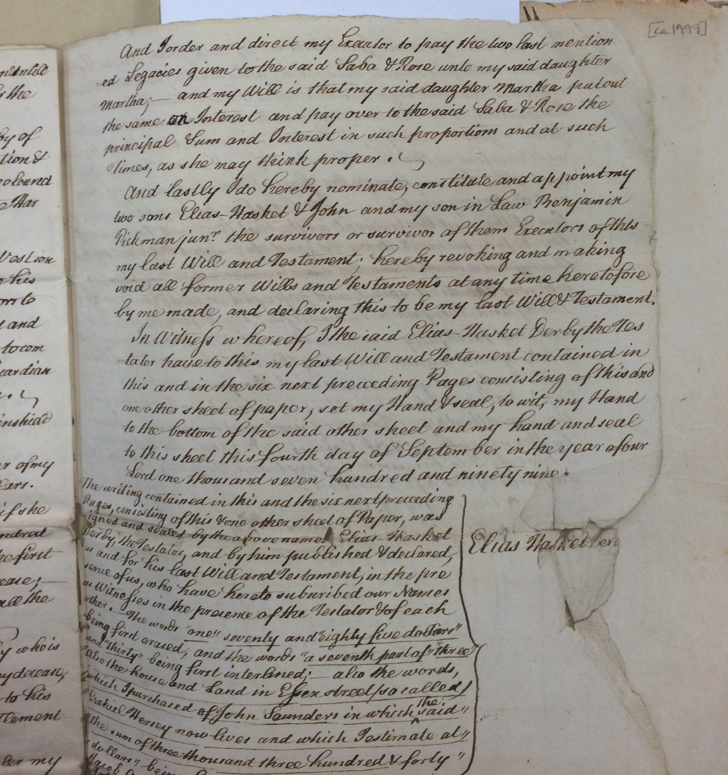

Image Source
Derby Family Papers, MSS37, Box 19 Folder 1
Courtesy of The Phillips Library, Peabody Essex Museum, Salem, Mass.

Document D

Sabe & Rose Marriage

Original Transcription

1799

December 9 Sabe Derby & Rose Lane, Negroes

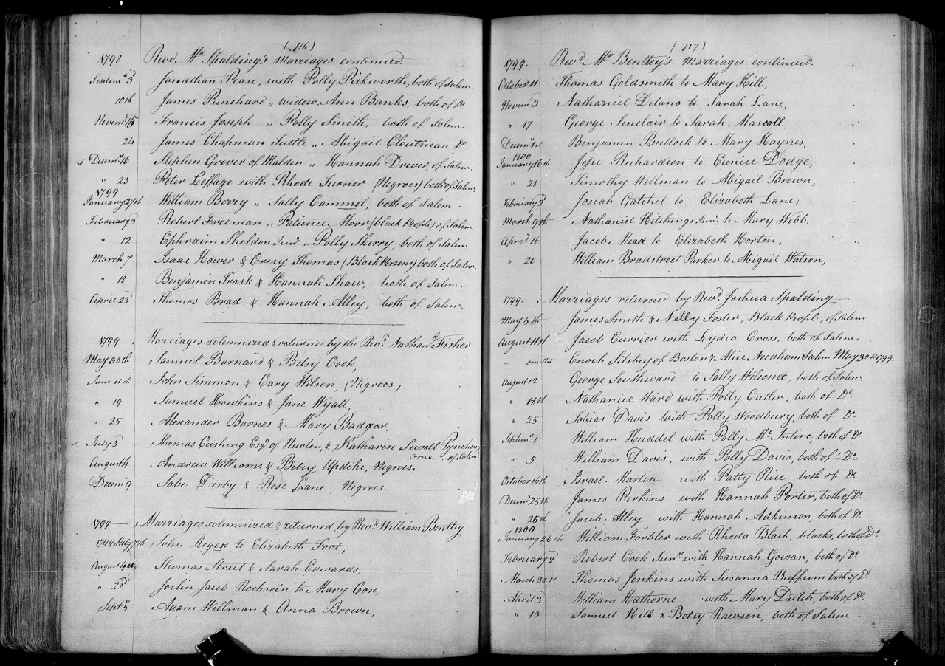
Image Source

Document E

Rose’s Obituary

Original Transcription

Rose, wife of Saib Derby, Free blacks, both
formerly belonging to Elias Haskett Derby, Esq
an eminent merchant of Salem. The good qual-
ities of this woman had gained her just esteem,
and the funeral procession last Thursday, di
honor to the people of Colour, from the descent
manners and appearance of all who were
assembled on the occasion. The friends of hu-
manity are delighted when they see such une-
quivocal proofs of the good habits and rising
hopes of a once oppressed part of civil society.

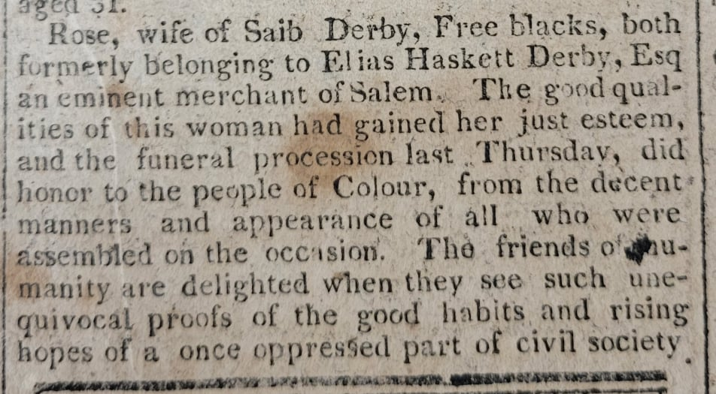

Image Source:
“The Essex Register”, Saturday, June 3, 1809. Museum of Printing, Haverhill, MA. NPS Photo.

